How to create an Alma Analytics report of all ordered items that have not yet been received | 

Yoel Kortick
Senior Librarian

ONE
From Alma do menu “General > Analytics > Design Analytics”

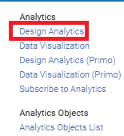

TWO
From Analytics do “Create > Analysis” and choose subject area “Funds Expenditure”

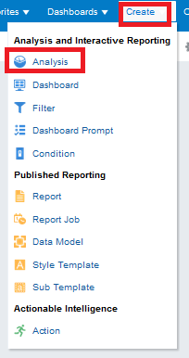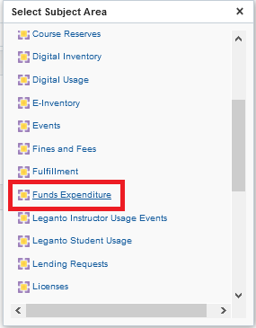

THREE
Add the desired fields to the report for example:
"Bibliographic Details > Author"
"Bibliographic Details > MMS Id"
"Bibliographic Details > Title"
"PO Line > Expected Receiving Date"
"PO Line > PO Line Reference"
"PO Line > Receiving Status"

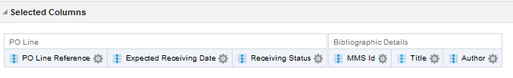

FOUR
Add filters on “Receiving Status” to get only “non-received” items”

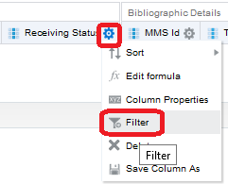

FIVE
Choose all the items that have not a receiving status = yes
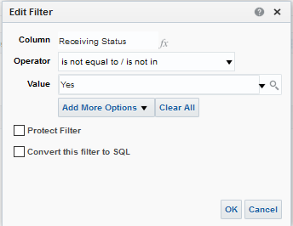

SIX
Filter on the “Expected Receiving date” and choose a value less than today:

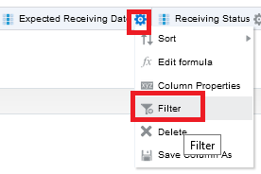

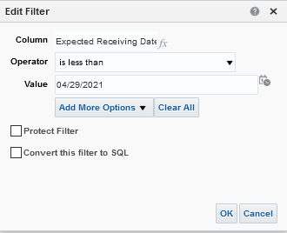

Note that instead of hard coding the expected receiving date to today it is possible to use sql to have it dynamically always use the current date. If you want to use a dynamic date via SQL:

In the filter choose to convert the filter to SQL

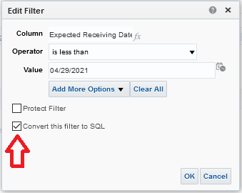

Then change the text of the filter to use current_date instead of a hard coded date

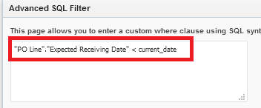

SEVEN
Run the report by clicking on the “Results” tab:

EIGHT

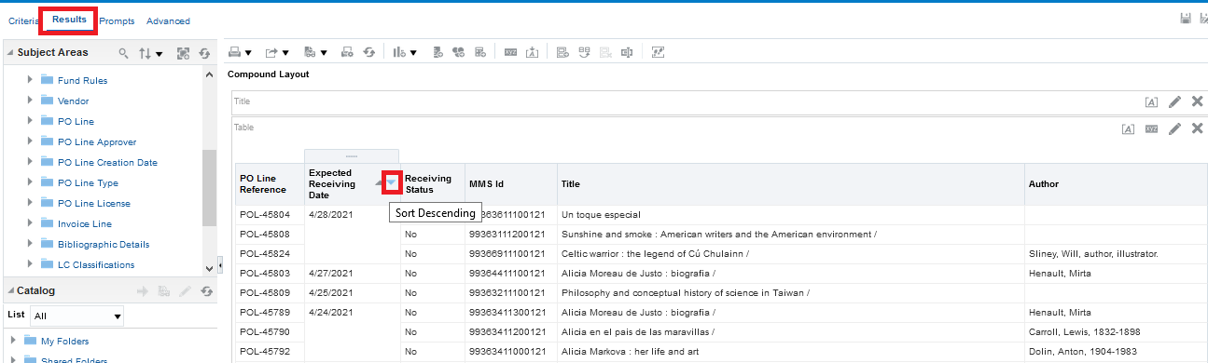

NINE

Click “Save As” on the top right and save the report in a desired location

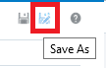

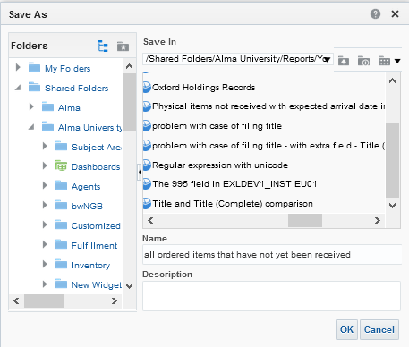

TEN
Let’s take a look at the first example, POL-45804

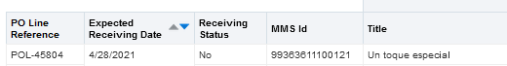

The POL is still in status “sent” and was supposed to arrive yesterday

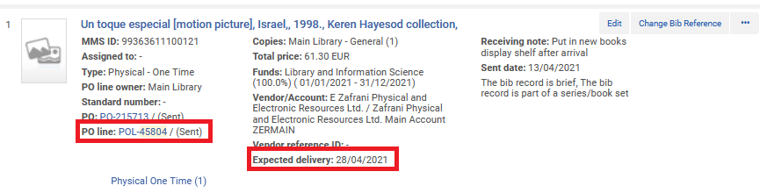

It also appears in the Receiving Workbench as having not yet arrived

